**SMTP configuration for email notifications on Jenkins Server:**

**Step 1**. Go to Dashboard >> Configure System

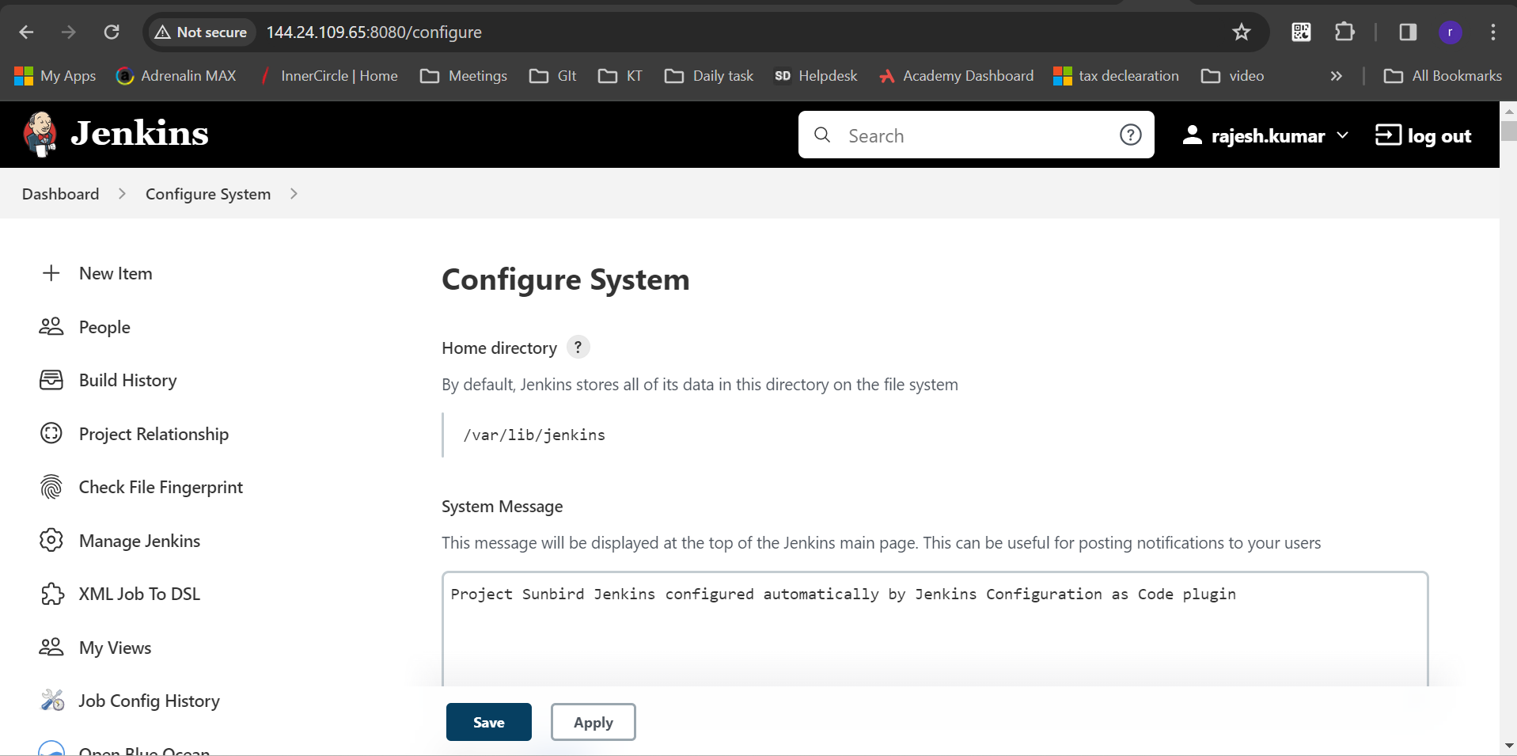

**Step 2**. Scroll down to E-mail notification and Update the SMTP server and click on advance option.

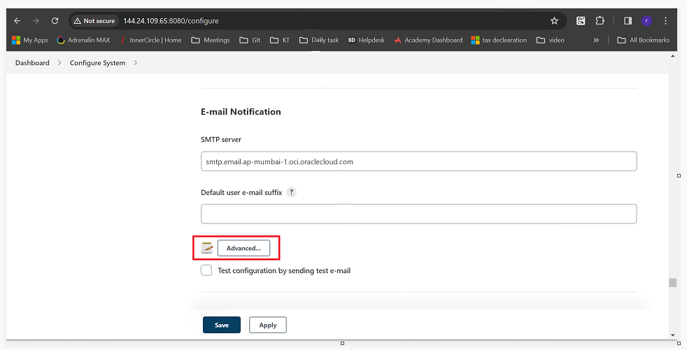

**Step 3**. Check mark on **Use SMTP Authentication** and update the **Username and password**. Check mark the Use **TLS** option. Also update the **SMTP port number** and **Reply-to address** with the email id where you want the email notification to be sent.

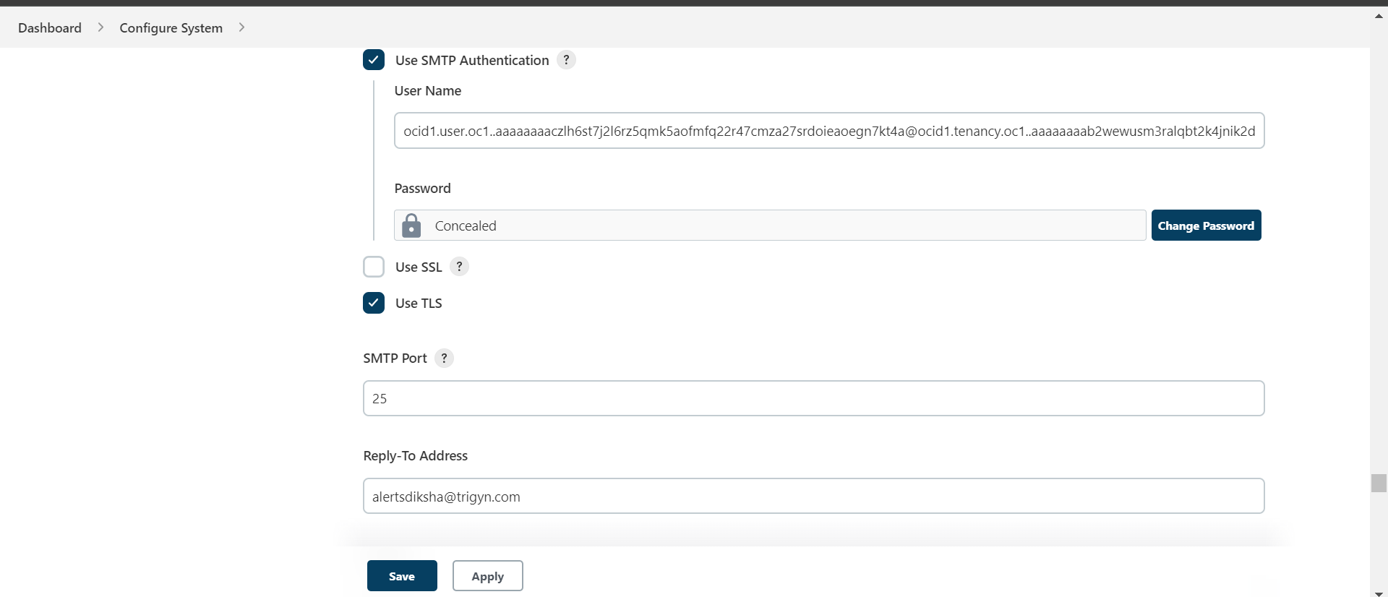

**Step 4.** Code changes required to be done in the Jenkins file for email notification for the particular pipeline.

At the end of the Jenkins file you can paste the below code.

***def email_notify() {***

***def buildNumber = env.BUILD_NUMBER***

***def jobUrl = env.JOB_URL***

***mail (***

***subject: 'Jenkins Pipeline Status',***

***body: """$JOB_NAME - Pipeline ${currentBuild.result}.***

***Build Number: $buildNumber***

***Job URL: $jobUrl***

***Hello, This is an email from Dev Jenkins pipeline.""",***

***to: 'alertsdiksha@trigyn.com'***

***)***

***}***

**Note:** Please click on the link for detailed [example](https://github.com/dicdiksha/sunbird-devops/blob/oci-5.1.0-check-status/pipelines/cassandra-monitoring/Jenkinsfile)